

DATA SHEET | PERFORMANCE DATA 6-CNFT-55 12V/55Ah

the power of tomorrow
CLEAN ENERGY DEFINES THE WORLD THAT WE LIVE IN TODAY AND TOMORROW. LEAD CRYSTAL® TECHNOLOGY CREATES POWER THAT IS CLEAN SAFE AND

HIGH PERFORMING FOR A BETTER FUTURE

SPECIFICATION
Nominal Voltage | 12V
Rated Capacity (10 hour rate) | 55 AH
Dimension Total Height (top of terminal) | 225 mm | 8.86"
Height | 222 mm | 8.74"
Length | 277 mm | 10.90"
Width | 106 mm | 4.17"

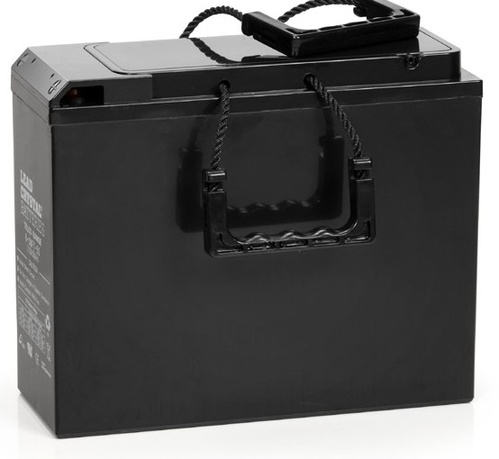
DISCHARGE CURRENT AND END VOLTAGE
Weight Approximately
16.8kg / 37.03 lbs

Discharge current (A)
0.05C or below or Intermittent discharge 0.05C of current close to it
0.1C of current close to it 0.2C of current close to it From 0.2C to 0.5C
From 0.5C to 1C From 1C to 3C
Current in excess of 3C
End voltage (V) 11.4
11.1
10.8
10.5
10.2
9.6
9.0
7.8
Capacity 25ºC

Internal Resistance
Self-Discharge 25ºC
120 hour rate (0.55A) 20 hour rate (3.0A) 10 hour rate (5.5A)
Fully charged Battery (25ºC)
Capacity after 3 month storage Capacity after 6 month storage Capacity after 12 month storage
66 AH
60 AH
55 AH

8m0

95%
85%
80%

CHARGE vs TEMPERATURE

2.7
VOLTAGE/CELL
2.6
2.5
2.4
2.3
2.2
2.1
2

CYCLE CHARGE FLOAT CHARGE

Max Discharge Current 25ºC
Terminal | Standard F3
Terminal | Optional
Charging (Constant Voltage) | Initial Charging  Cycle Current 16.5A  14.7V/ (25℃)
Charging (Constant Voltage) | Float 13.6V/ (25℃)

550A (5S)

-40 -35 -30 -25 -20 -15 -10 -5 0
TEMPERATURE (°C)
5 10 15 20 25 30 35 40 45 50 55 60 65 70


CHARGE vs TEMPERATURE CHART

temperature | -40 | -35 | -30 -25 -20 -15 | -10 -5 | 0 5 | 10 | 15 20 25 30 35 40 45 50 |  | 55 60 | 65 70
Cycle Charge | 2.66 2.64 2.62 2.60 2.58 2.56 |  |  | 2.54 2.52 2.50 2.48 |  | 2.47 2.47 |  | 2.45 2.45 2.43 2.41 2.39 2.37 2.35 2.33 2.31 |  | 2.29 2.27
Float Charge (voltage/cell) | 2.46 2.44 2.42 2.40 2.38 2.36 |  |  | 2.34 2.32 2.31 2.30 |  | 2.29 2.29 |  | 2.29 2.27 2.26 2.24 2.23 2.23 2.23 2.23 2.23 |  | 2.23 2.23

CONSTANT CURRENT DISCHARGE CHARACTERISTICS: UNITS AMPERES (25°C)

End Voltage per cell | 5min 15min 30min 45min | 1h 2h 3h 4h | 5h | 6h | 8h | 10h | 12h | 20h | 24h
1.60V | 201.83 106.81 64.54 47.05 | 37.90 21.71 15.77 12.37 | 10.55 | 8.97 | 6.84 | 5.69 | 4.78 | 3.11 | 2.54
1.67V | 187.57 103.31 63.58 46.73 | 37.83 21.62 15.48 12.30 | 10.40 | 8.90 | 6.83 | 5.63 | 4.77 | 3.10 | 2.53
1.70V | 185.66 101.73 62.94 46.10 | 37.52 21.43 15.39 12.24 | 10.24 | 8.81 | 6.80 | 5.63 | 4.75 | 3.09 | 2.53
1.75V | 170.08 98.54 62.32 45.78 | 36.88 21.01 15.32 12.08 | 10.14 | 8.74 | 6.77 | 5.56 | 4.73 | 3.08 | 2.52
1.80V | 152.59 92.18 59.76 44.51 | 35.92 20.70 15.26 12.05 | 10.01 | 8.65 | 6.74 | 5.50 | 4.71 | 2.97 | 2.52
1.83V | 145.86 84.57 58.82 42.92 | 34.34 20.51 14.66 11.54 | 9.79 | 8.33 | 6.60 | 5.28 | 4.51 | 2.94 | 2.49
1.85V | 136.69 82.02 55.00 41.33 | 33.38 19.68 14.27 11.38 | 9.54 | 8.05 | 6.52 | 5.21 | 4.45 | 2.91 | 2.46

DISCHARGE DATA WITH CONSTANT POWER UNITS: WATTS PER CELL (25°C)

End Voltage per cell | 5min 15min 30min 45min 1h 2h 3h 4h | 5h | 6h | 8h | 10h | 12h | 20h | 24h
1.60V | 337.26 187.55 120.79 88.05 70.83 41.01 29.98 23.75 | 20.06 | 17.23 | 13.29 | 11.00 | 9.25 | 6.17 | 5.05
1.67V | 321.05 184.69 115.91 87.42 70.89 41.01 29.59 23.71 | 20.06 | 17.20 | 13.29 | 10.97 | 9.25 | 6.17 | 5.05
1.70V | 319.14 183.41 115.85 87.42 70.25 40.69 29.53 23.63 | 19.74 | 17.07 | 13.19 | 10.87 | 9.15 | 6.13 | 5.05
1.75V | 297.21 181.19 115.98 87.42 69.93 40.37 29.47 23.59 | 19.68 | 16.94 | 13.13 | 10.80 | 9.15 | 6.13 | 5.02
1.80V | 272.74 171.97 113.48 85.83 69.62 40.37 29.44 23.52 | 19.55 | 16.94 | 13.10 | 10.74 | 9.15 | 5.98 | 5.02
1.83V | 263.20 157.98 112.53 83.28 66.75 40.05 28.61 22.73 | 19.33 | 16.40 | 13.10 | 10.43 | 9.00 | 5.91 | 4.99
1.85V | 243.81 154.49 104.58 80.11 64.85 39.10 27.81 22.44 | 18.79 | 16.08 | 12.59 | 10.33 | 8.84 | 5.85 | 4.96

6-CNFT-55 12V/55Ah

CYCLE CHARGE CHARACTERISTIC (25°C) FLOATING CHARGE CHARACTERISTIC (25°C)

REGULAR CYCLE CHARGE CHARACTERISTICS 77°F (25°C) FLOATING CHARGE CHARACTERISTICS 77°F (25°C)

CHARGE CHARGING CHARGING
CHARGE CHARGING CHARGING

CAPACITY CURRENT
VOLTAGE
CAPACITY CURRENT
VOLTAGE

(%)
120

100

80

60

40

20

0
(CA)

0.30

0.24

0.18

0.12

0.06

0.00
(V)

14.7
CHARGING VOLTAGE
CHARGE CAPACITY
CHARGING CURRENT

13.6

12.3

11.1

0 3 6 9 12 15 18
TIME (H)
(%)

110
100

80

60

40

20

0
(CA)

0.10

0.08

0.06

0.04

0.02

0.00
(V)
14.0
CHARGING VOLTAGE
CHARGE CAPACITY
CHARGING CURRENT

13.2

12.4

11.6

10.8

0 5 10 15 20 25 30
TIME (H)

CYCLE LIFE CURVE GRAPH
CAPACITY RATE (%)

CYCLE LIFE CURVE GRAPH ( 2 5 °C)
CAPACITY RATE (%)
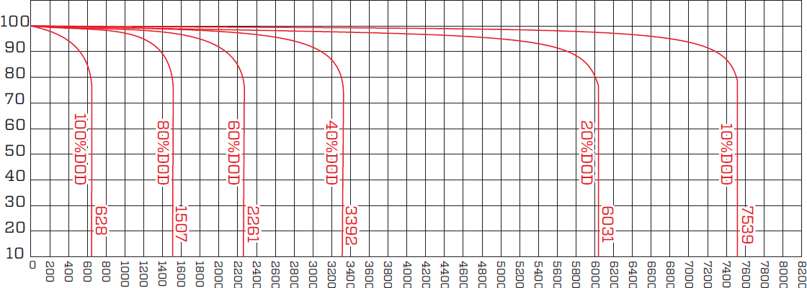

NUMBER OF CYCLES
CYCLE LIFE CURVE GRAPH ( 4 0 °C)
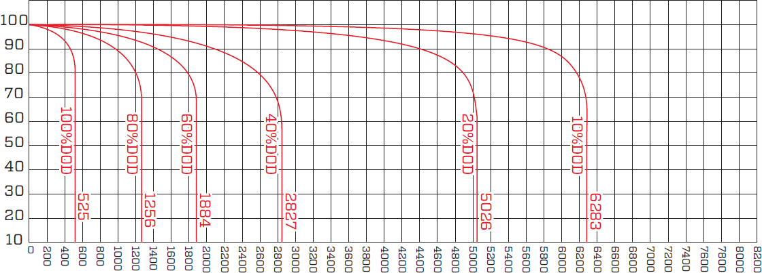
NUMBER OF CYCLES

TEMPERATURE & FLOAT SERVICE LIFE FLOAT SERVICE LIFE CURVE GRAPH

100
CAPACITY RATE (%)
90
80
70
60
50
40
30

 | 60 | ºC | 5 | 0ºC |  |  | 40ºC |  |  | 25ºC
0 1 2 3 4 5 6 7 8 9 10 11

SERVICE LIFE YEAR (YEAR)

TEMPERATURE & DISCHARGE CAPACITY
22
20
18
16
14
12
LIFE (YEAR)
10
8
6
4
2
0
0 10 20 30 40 50 60

TEMPERATURE (°C)

120
DISCHARGE RATIO ( %)

100

80

60

40

20

0

40 30 20 10 0 10 20 30 40 50 60

TEMPERATURE (°C)
0.05CA
  - CA

  - CA
0.5CA









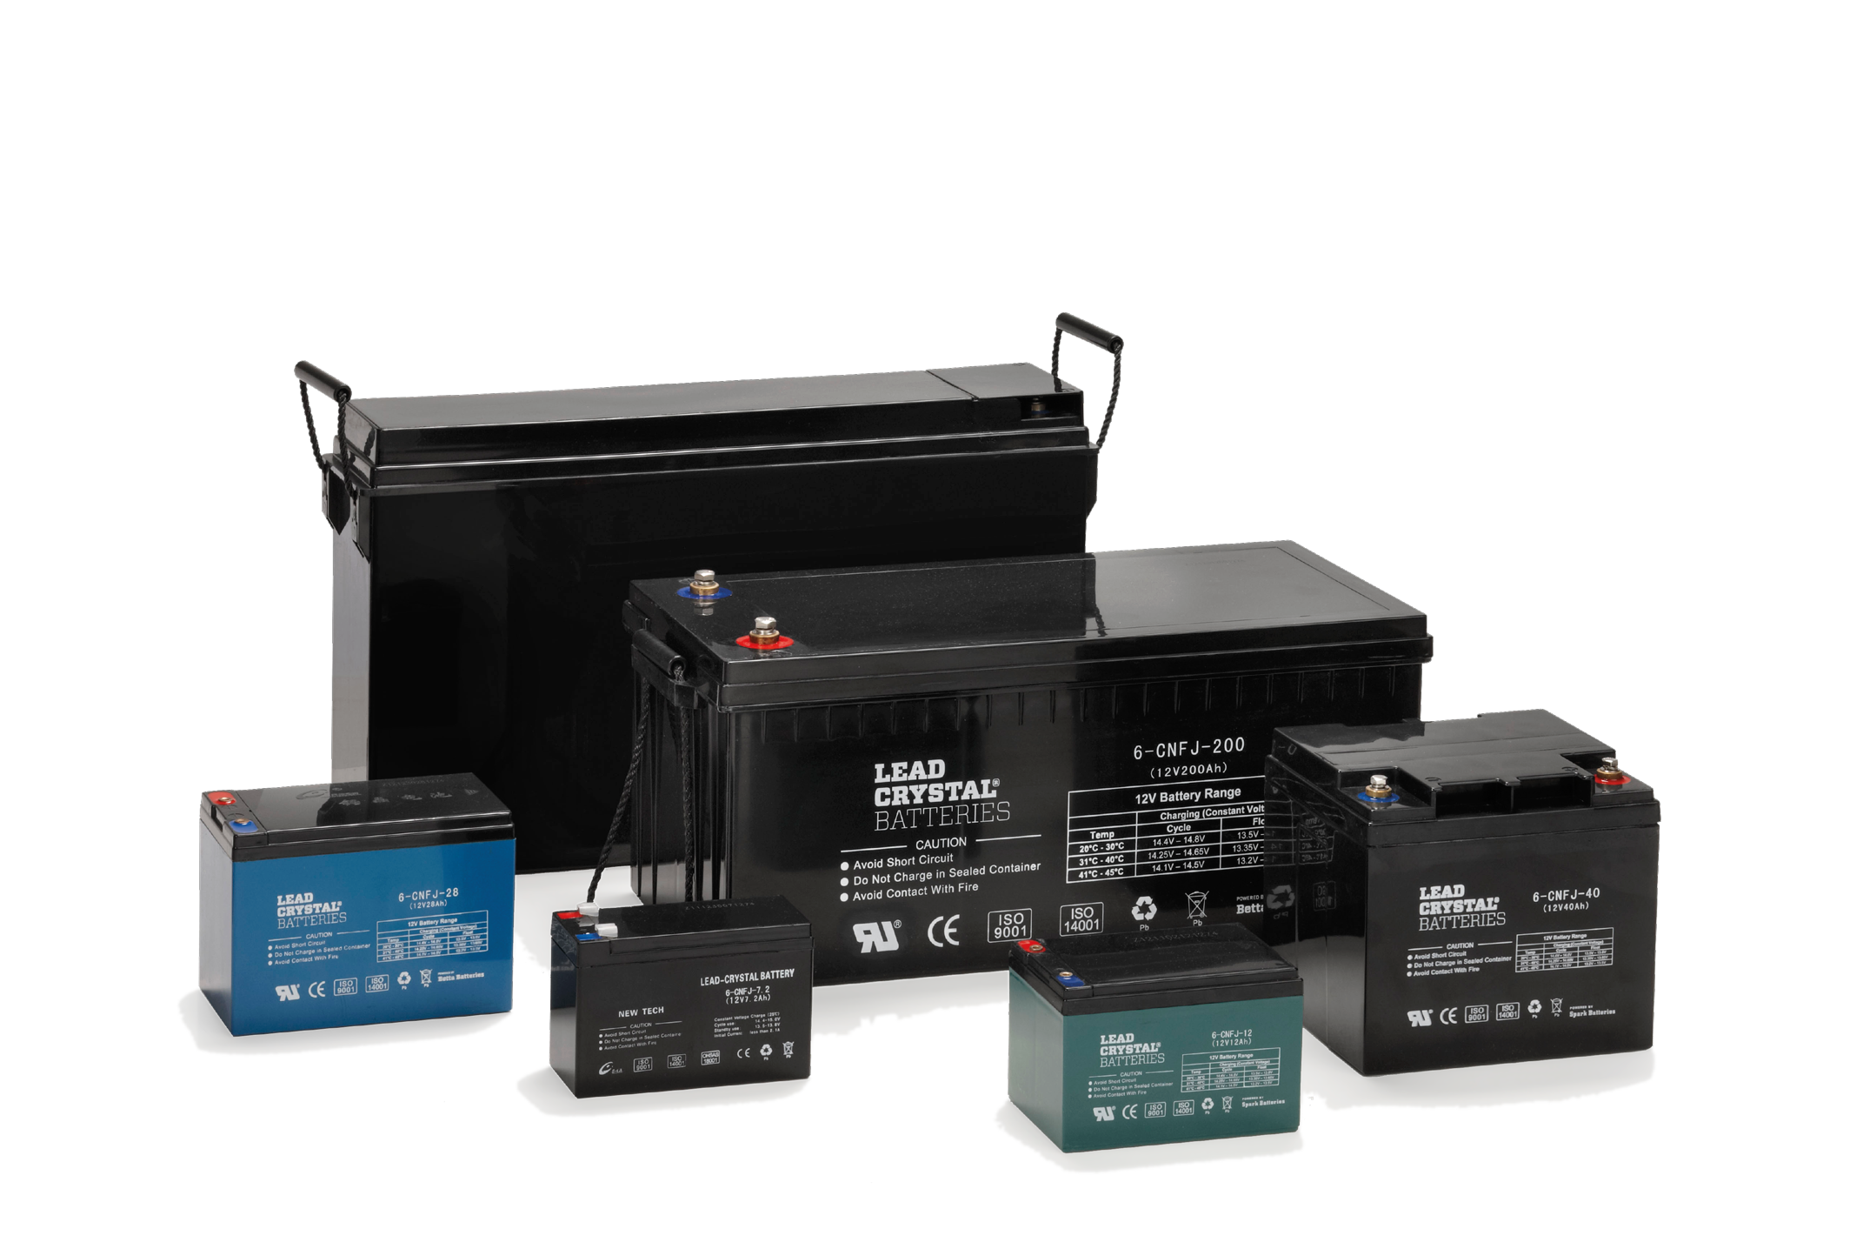
6-CNFT-55 12V/55Ah

LEAD CRYSTAL®:
CHANGING THE FUTURE

Performance Robust, resilient, high performing. Lead Crystal® batteries can be discharged deeper, cycled more often (also in extreme temperatures) and have a longer service life. They recover to full rated capacity over and over again.

Technology A unique micro-porous high absorbent mat (AGM), high-purity lead calcium selenium plates, safe SiO2 electrolyte solution that solidifies into a white crystalline powder when charged/discharged.

Cleaner & safe Less acid, no cadmium, no antimony. Lead Crystal® batteries are up to 99% recyclable and are classified as non-hazardous goods for transport.

Markets Lead Crystal® batteries are being used in telecoms, ups, petrochem/marine, defence, renewable energy, health care, manufacturing, transportation and electric motion (wheelchairs, golf carts & trolleys).

https:// leadcrystaltechnologies.com

